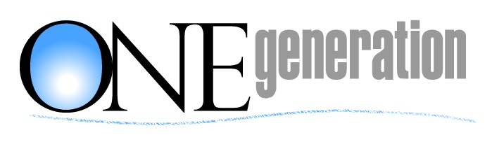

INVOICE

January 13, 2019

North Hills West Neighborhood Council

REMIT PAYMENT TO:
ONEgeneration Senior Enrichment Center
18255 Victory Blvd.
Reseda, CA 91335
818-705-2345

2019 Senior Symposium

Item | Amount
Senior Symposium Participation –  Booth, Canopy, Table with 2 chairs, and inclusion of logo on flyers, banners, programs and other outreach materials for the May 18, 2019 Senior Symposium | $750.00
Balance Due | $750.00

