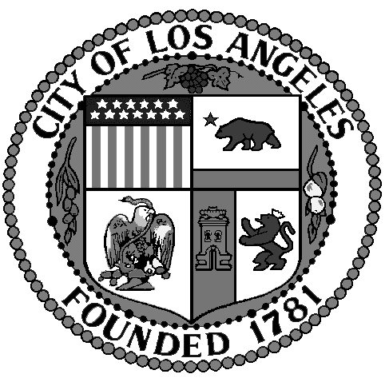

NORTH HILLS WEST NEIGHBORHOOD COUNCIL
Rules & Elections Committee Meeting Minutes, Tuesday, January 14, 2020
at Mid-Valley Regional Library, 16244 Nordoff St., North Hills, CA 91343
DRAFT Minutes [to be replaced by “Approved _[Month]_ _[date]_, 201_[year]_”]

NHWNC (and all other) Meeting Minutes are a summary; Minutes were not, are not and are never meant to be an exact, verbatim, word-for-word transcript or comprehensive record of what was said at a Meeting. Exceptions: Motion(s) (included as stated at the Meeting, or, if not stated, as written on the Agenda); quotes (words that have quotation marks (“”) at the beginning and ending of a word or words); and Agenda wording copied into the Minutes.

1. Welcome and Flag Salute; Roll Call and announcement of quorum and qualifications.
Chair Punam Gohel called the Meeting to order at 4:01 p.m. Roll Call: all three Committee Members were present: Punam Gohel (Chair), Pat Crone and Dave Brown. The Committee quorum (the minimum number of Committee Members needing to be present to take binding votes on Agendized Items) is two (see the Bylaws at https://lacity.quickbase.com/db/bj3apxsp3?a=q&qid=32&qskip=0&qrppg=1000&dlta=su46~), so the Committee could take such votes. Also attended: three Stakeholders and guests.

2. Discussion and possible motion to Approve Previous Meeting Minutes
Copies were distributed of the July 15, 2019 Minutes.

MOTION (by Mr. Brown, seconded by Mr. Gohel): The North Hills West Neighborhood Council approves the Minutes of its July 15, 2019 Committee Meeting as written.

MOTION PASSED unanimously by a hand vote of all three Committee Members present; zero opposed; zero abstained.

3. General Public Comments
There were no comments at this time.

4. Public Representatives Comments
No representatives were present; there were no comments.

5. Comments by Chair and discussion of topics from last meeting
There was discussion of what issues to recommend for the Board to consider. Ms. Crone wanted the Board to “take a stand” on State Senate Bill 50 and on the Bus Rapid Transit (BRT) / Transit-Oriented Development (TOD) project. Mr. Brown wanted the Board to consider street vending, street markings and hazardous driving.

6. Discussion & possible action to recommend new members to the R&E Committee
There were no recommendations at this time.

7. NHW Neighborhood Council Committee 2021 Election discussion
Copies were distributed of the “Current NHWNC Board configuration.” There was extensive discussion of what Board Seat designations to have. Currently, there are seven Residential, five General and one Community Interest Seats. Mr. Brown suggested having six Residential, six At-Large and one Community Interest Seats. He noted that the current configuration is in conflict with the Bylaws. Concern was expressed regarding a potential At-Large Seat designation because it could expose the Board to a takeover. The Committee discussed the Board having five Residential, five General, two At-Large and one Community Interest Seats.

8. Review & discussion regarding current NC Standing Rules
Copies were distributed of and Mr. Brown read aloud the Standing Rules. The Committee agreed to add Rule #11 onto the end of #10; #12 would become a new #11. There was discussion of the intent and wording of #12/new #11. It was agreed that the #12/new #11 wording would be “11. Any individual Board or committee member is free to speak or write expressing his or her own opinion in a public venue or media outlet as long as the views expressed are stated to be representing that person’s opinion only.” There was discussion of whether a speaker at a public meeting (other than an NHWNC meeting) should identify themselves as a Board Member (if they are) and say that they are not speaking for a Neighborhood Council, or the speaker simply to say that they are “speaking as a private citizen.”

9. Review & discussion regarding current NC Bylaws
This Item was not addressed.

10. Committee Member Comments
There were no comments at this time.

11. Requests For Future Agenda Items
There were no requests at this time.

12. Motion to Adjourn
Mr. Gohel declared the Meeting ADJOURNED at 5:37 p.m.

The first paragraph of some Items, Motions/Resolutions and other wording may have been copied from the Agenda. Minutes written by DL, possibly edited by NHWNC. The NHWNC Minutes page is http://www.nhwnc.net/agendas-minutes/minutes-and-agendas.

