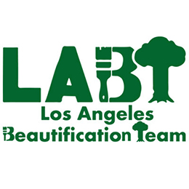

Steps to plant a tree in your parkway.

Identity address

CTW’s requires Commitment to water for 3 years.

Person at the address in front of the possible tree planting must give permission (CTW- Commitment to Water) and that person or another party has to promise to water for three year. A neighborhood or a BID or similar group can take the responsibility for water if need be.

Request trees through 311 system.

The city will assign a partnering non-profit to inspect the site and validate the site condition and infrastructure and that it meets the City requirements for tree planting.
If approved the non-profit will apply for a permit to the City to plant the tree.

The Urban Forestry Dept will send out their inspector to validate the location. If the location meets City’s standard, a permit is then issued.

The City inspector selects the tree species, usually based on the environment in the neighborhood. Constituents can have input in the tree species selection. The City inspector makes the final decision.

This process can take up to 4 months.

The non-profit will come back with the planting.
The non-profit will contact the constituent if they would like to participate in the planting.

If a concrete cut is required, that entails a separate permitting process. City Plants program supplies the tree and the labor for tree planting but does not generally have funding for concrete cutting and removal.

Different organization like a Neighborhood Watch, Neighborhood Council, BID, etc. can organize neighborhood plantings. They should begin by identifying places to plant and empty tree wells. There must be a CTW for every location. The organization can sign the CTW for the various addresses which means they will have to water these addresses for 3 years.
The merchant or resident at the designated location has the right to refuse the tree and must be notified in advance of the permitting process.

A neighborhood organize can collect CTW’s, submit them to the City, work with the non-profit planting partner and create a neighborhood event so that community members can come out and plant.

The coordinating organization can pay a qualified third party to do the tree care and watering.

Through the LA DWP and City Plant programs, private property “free yard trees” program offer up to 7, 5-gallon trees to shade your property. You can also request a “Tree Giveaway” event in your neighborhood hosted by one of the planting partners. You pre-order online and the host then sets up a curbside distribution in your neighborhood.

1741 North Cherokee Avenue, Hollywood CA 90028 Ph. 323-962-2163 Fax 323-957-1495
HBT@labteam.org Web Site: www.hbteam.org
A California Non-Profit Corporation 501 (C) 3 Fed. Tax ID 95-4358515

